We will be closed Monday October 9th, 2023 in observation of
Indigenous People Day
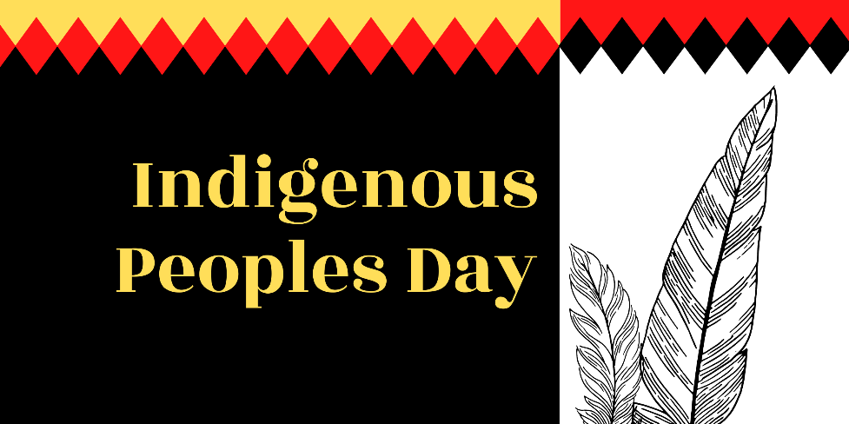
We will reopen Tuesday October 10th, 2023 at 8:00am

