**WE WILL BE CLOSED**

**Thursday November 23rd and Friday November 24th to observe Thanksgiving.**

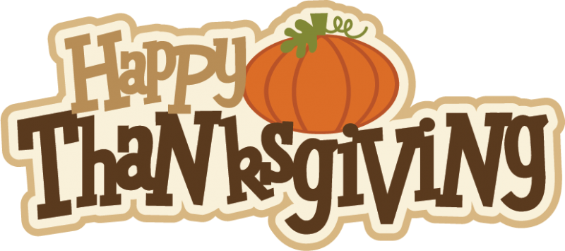

[This Photo](https://jobsanger.blogspot.com/2014/11/happy-thanksgiving.html) by Unknown Author is licensed under [CC BY-NC-ND](https://creativecommons.org/licenses/by-nc-nd/3.0/)