Town of Hebron Driveway Ordinance
Enacted March 17, 2001
Amended March 21, 2015
Amended March 17, 2018

Section 1. Title

This Ordinance shall be known and cited as the Town of Hebron, Maine Driveway Ordinance, and will be referred to as "this Ordinance."

Section 2. Purpose

The purpose of this Ordinance is to protect the health, safety and general welfare of the inhabitants of the Town of Hebron by establishing entrance standards for driveways and standards for common driveways.

Section 3. Authority

This Ordinance is hereby adopted and hereafter amended pursuant to and consistent with Article VIII-A of the Maine Constitution and Title 30-A M.R.S.A. § 3001 (Home Rule).

Section 4. Applicability

This Ordinance applies to the first-time construction and alterations of private driveway entrances and common driveways for which construction begins after the effective date of this ordinance. For driveways that enter Route 119 or Route 124, if a provision of this Ordinance conflicts with a provision of the Highway Driveway and Entrance Rules issued by the Maine Department of Transportation, the more restrictive provision shall apply.

Section 5. Amendments, Validity and Severability, Effective Date and Repeal of Existing Ordinances

- Amendments

  - An amendment to this Ordinance may be brought before a town meeting by:

    - The Planning Board provided a majority of the Board has so voted;

    - The Board of Selectmen provided a majority of the Board has so voted; or

    - A written petition of a number of voters equal to at least 10% of the number of votes cast in the municipality in the last gubernatorial election.

  - An amendment to this Ordinance may be adopted by the majority vote of regular or special town meeting.

- Validity and Severability

Should any section or provision of this Ordinance be declared by any court to be invalid, such decision shall not invalidate any other section or provision.

- Effective Date

The effective date of this Ordinance is the date of adoption by the Town Meeting. The effective date of any future amendments to this Ordinance will be the date of the adoption by the Town Meeting. The effective date of any invalidation to this Ordinance is the date of the court ruling or the effective date of the statute resulting in the invalidation.

- Repeal of Existing Ordinances

Adoption of this Ordinance shall repeal on the effective date of this Ordinance all previously enacted Driveway Ordinances. This shall not prevent enforcement of repealed ordinances with respect to the time periods in which they were effective.

Section 6. Administration

- Installation of a private driveway or alterations to the entrance of an existing private driveway or construction of a common driveway must first obtain a driveway permit.

- Applications for permits shall be submitted in writing. The Code Enforcement Officer may require the submission of information which is necessary to determine conformance with the provisions of this Ordinance.

- It is the responsibility of the property owner or his /her agent to clearly mark the area where the driveway entrance / curb cut is to be established.

- All permits shall be approved, approved with conditions, or denied within fourteen (14) days of receipt of a completed application.

- All permits issued by the Code Enforcement Officer shall expire if a start to construction has not begun within two (2) years after the date on which the permit was issued except as may be provided for in other sections. Upon good cause shown, the Code Enforcement Officer may extend the permit for an additional six months. After the expiration of the time periods set forth above, permits shall lapse and become void.

- It shall be the responsibility of the Road Foreman to determine if a culvert is needed within the town's right of way. If so, the length, diameter and type of culvert shall be determined by the Road Foreman. Said determination shall be based on the existing drainage system for that road.

- First time construction is charged to the permit holder at Town of Hebron culvert cost. The culvert once installed, inspected, and accepted by the Town of Hebron, becomes the property of the Town of Hebron. A driveway culvert determined to need replacement shall be the full responsibility of the Town.

- The Town has the option to reject all driveway culverts installed by anyone other than the Town Public Works Department.

- The Board of Selectmen may, from time to time, establish the appropriate permit fees following posting of the proposed fees and public hearing.

Section 7. Standards

  - Private Driveways Serving Individual Lots

    - The driveway entrance shall be located to meet the following recommended sight distances in both directions. Where the recommended sight distances are not achievable, the Code Enforcement Officer shall require that the driveway be located where they are met to the maximum extent.

Posted Speed Limit | Sight Distance
25 MPH | 200'
30 MPH | 250'
35 MPH | 305'
40 MPH | 360'
45 MPH | 425'
50 MPH | 495'

    - The minimum slope within five (5) feet of the driveway's intersection with the street shall be at least 1% sloping away from the roadway. The maximum grade between five (5) feet and fifteen (15) feet of the driveway's intersection with the street shall not exceed ten (10) percent. (See Diagram 1 below.)

    - The driveway surface and ditches shall be stabilized to prevent erosion onto public roads and into ditches.

    - Drainage and roadside ditches shall not be impeded. The applicant shall provide, at the applicant's expense, suitable drainage structures, culverts, or other
constructed drainage at all entrances as approved by the Road Commissioner or his designee.
    - The driveway shall intersect with the road at an angle as close to 90 degrees as possible as site conditions permit, but no less than 60 degrees.

    - Prior to the issuance of a driveway permit required by this Ordinance, the applicant shall show proof of a Driveway/Entrance Permit issued by the Maine Department of Transportation if the proposed driveway will enter Route 119 or Route 124.

  - Common Driveways

    - Common driveways may serve two single-family dwelling units. The Code Enforcement Officer shall review and approve all plans for common driveways.

    - In addition to the standards contained in Section 7(A)(1)-(6) above, the following design and construction standards shall apply to common driveways.

      - Minimum trave width 12 feet
      - Minimum angle of street intersections 60 degrees
      - Maximum grade within 15 feet of intersections 10 percent

Section 8. Enforcement

- It shall be the duty of the Code Enforcement Officer to enforce the provisions of this Ordinance unless otherwise stated herein.

- Whoever willfully violates the provisions of this Ordinance shall, upon conviction, be penalized in accordance with Title 30-A M.R.S.A. Section 4452.

Section 9. Appeals

If the Code Enforcement Officer denies a permit or grants a permit with conditions that are objectionable to the applicant, an abutting landowner or any aggrieved party, or when it is claimed that the provisions of this Ordinance do not apply, or that the intent and meaning of the Ordinance has been misconstrued or wrongfully interpreted, the applicant, an abutting landowner or aggrieved party may appeal the decision of the Code Enforcement Officer in writing to the Board of Appeals within thirty (30) days of the date of the decision. The concurring vote of a majority of the members of the Board of Appeals present and voting shall be necessary to reverse an order, requirement, decision, or determination of the Code Enforcement Officer.

Section 10. Definitions

Alteration: Changing the location, width, or grade of a driveway entrance. Alteration does not include driveway maintenance so long as it does not affect the 1% grade away from the road within five feet of the road per Section 7(A)(2).

Common Driveway: A vehicle access way serving two (2) dwellings. Driveway: A vehicle access way serving one dwelling or one lot.
First-time construction: The clearing, excavation and filling associated with the placement of a driveway to serve a lot where a driveway did not previously exist.

TYPICAL DRIVEWAY CROSS SECTION-DIAGRAM

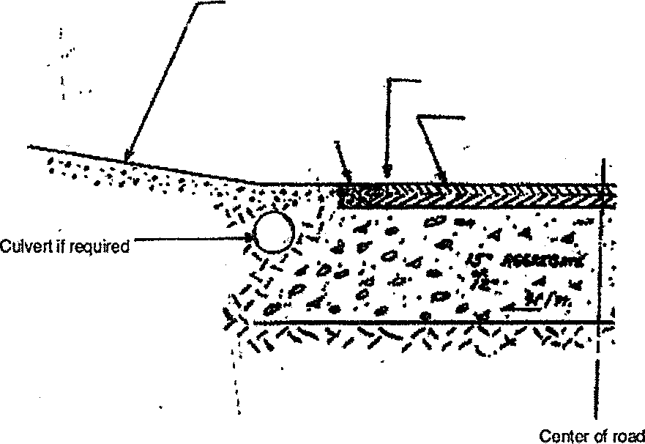
' •
From 5 to 15 foe!: Maximum sbpo is 10%
;
from EOP to 5' minimum 1% sI6pe, away from roadI, ,
Edge of pavement (of road)
- •f
Road urface • I:
' .

Diagram 1

