We will be closed Monday October 14th, 2024 in observation of

Indigenous People Day

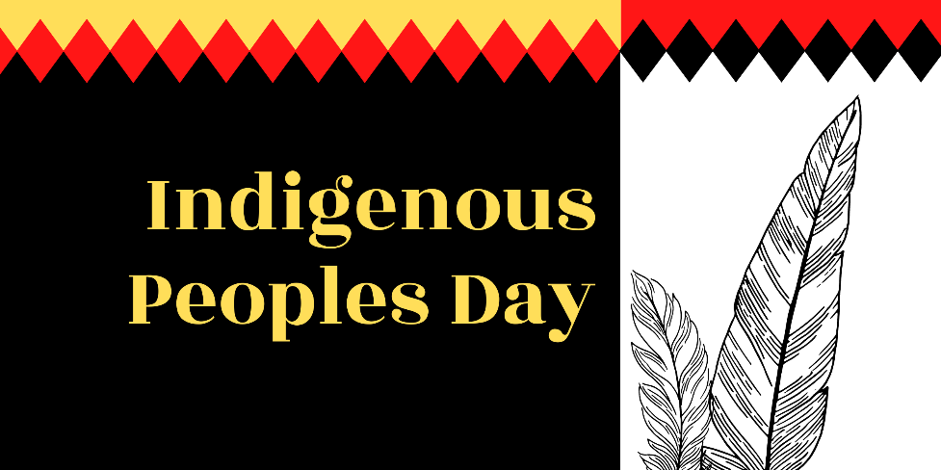

We will reopen Tuesday October 15th, 2024 at 8:00am