WE WILL BE CLOSED
Thursday November 28th and Friday November 29th to observe Thanksgiving.

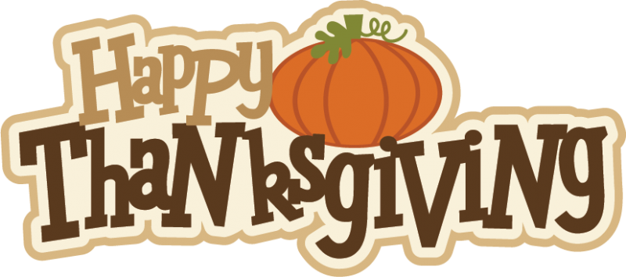
This Photo by Unknown Author is licensed under CC BY-NC-ND

