WE WILL BE CLOSED
Thursday November 27th and Friday November 28th to observe Thanksgiving.

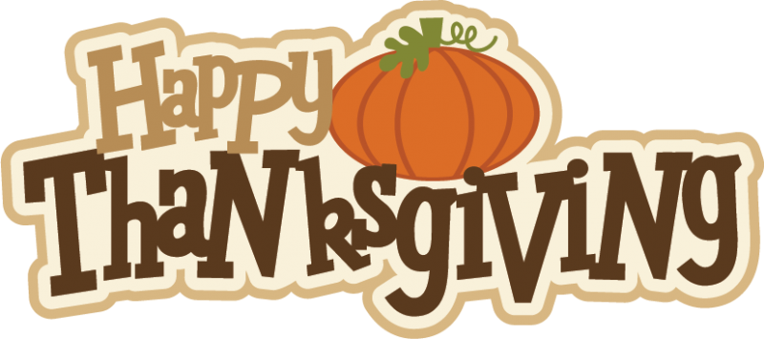
This Photo by Unknown Author is licensed under CC BY-NC-ND

